|  |  |
| --- | --- |
| Classification | Confidential |
| Doc Number |  |
| Date | 2013-08-25 |
| Version | V1.0a3 |

**OPP SOP**

Kai_Cui

**Table of Content**

**What the OPP is?**

**How to use it?**

**Application**

**How to drawing the distribution chart?**

1. **What the OPP is?**

OPP is the professional mapping software for us. It only can be used in the MAC computer. We can easily finish the distribution chart about the test station by using it. Below is the logo of OPP:

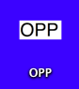

(1)

Double click the logo to open it and the UI is as below:

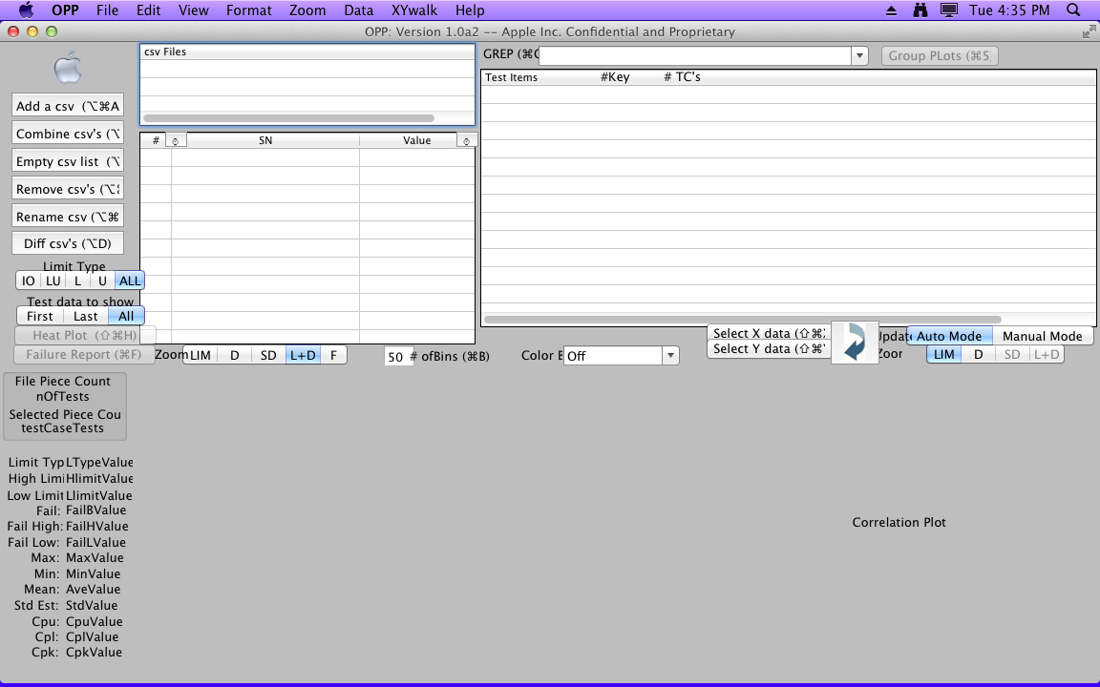

(2)

1. **How to use it?**
2. Add the CSV log and then you will get the distribution.

The step is as below:

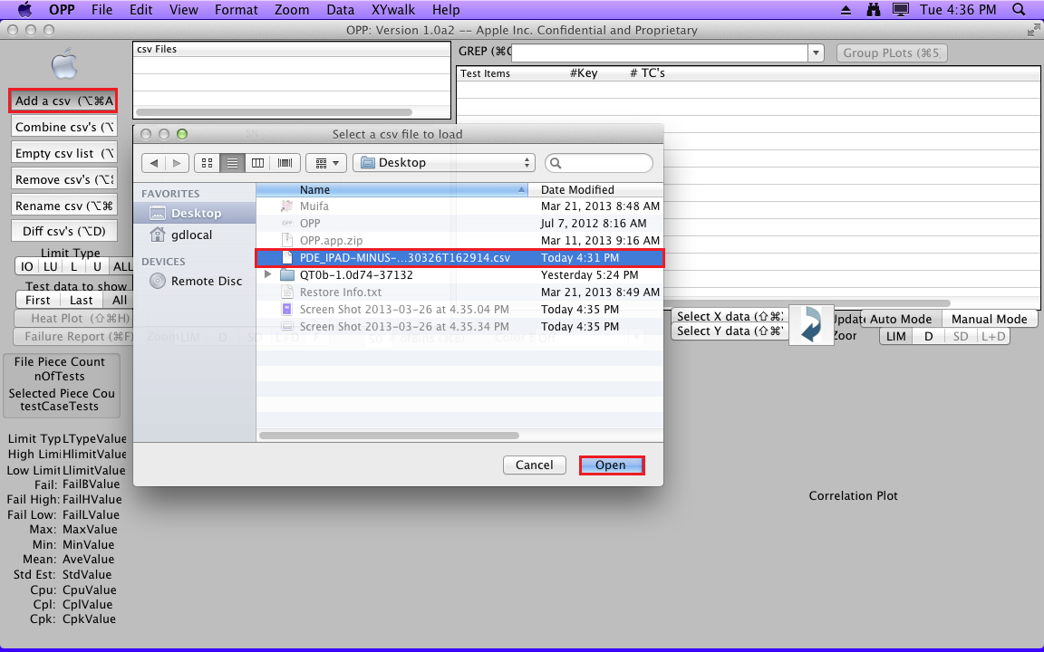

(3)

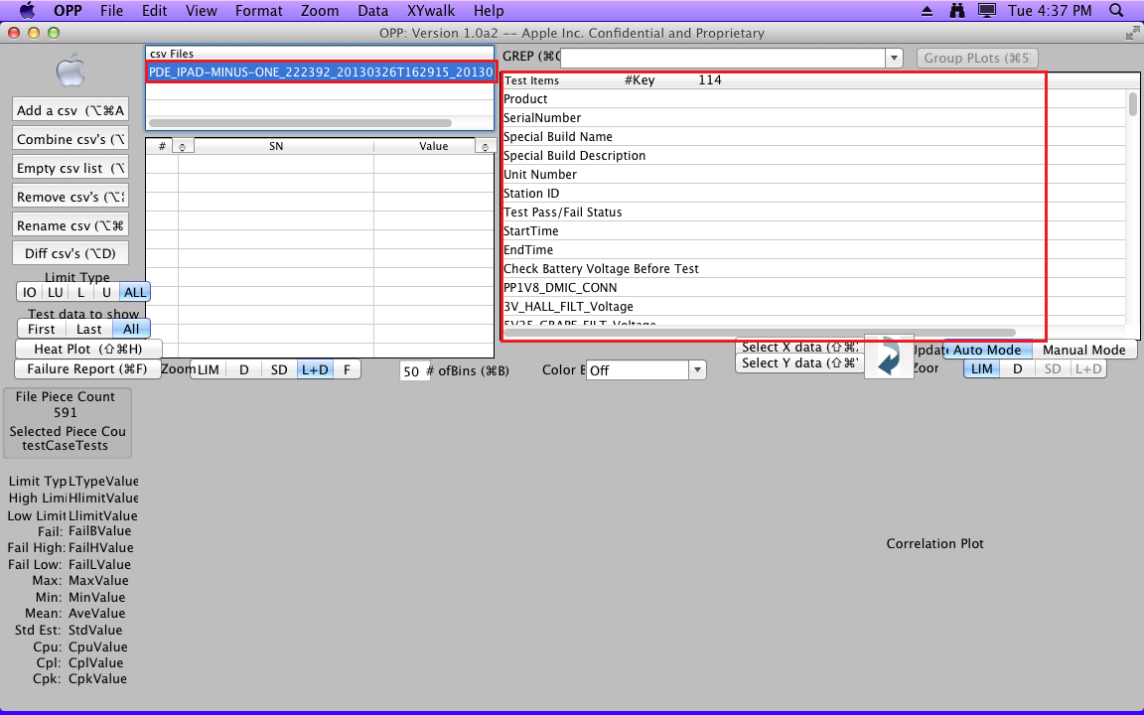

(4)

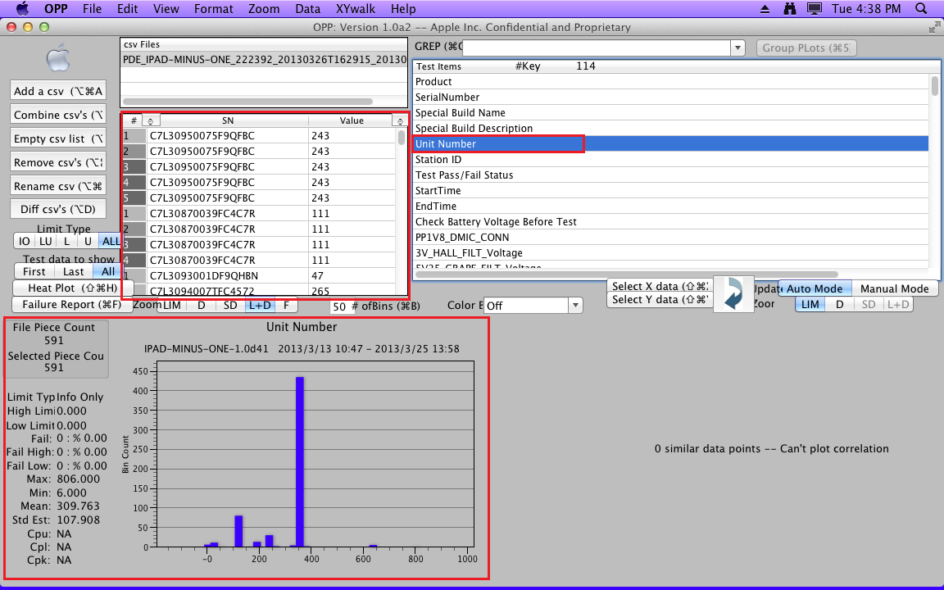

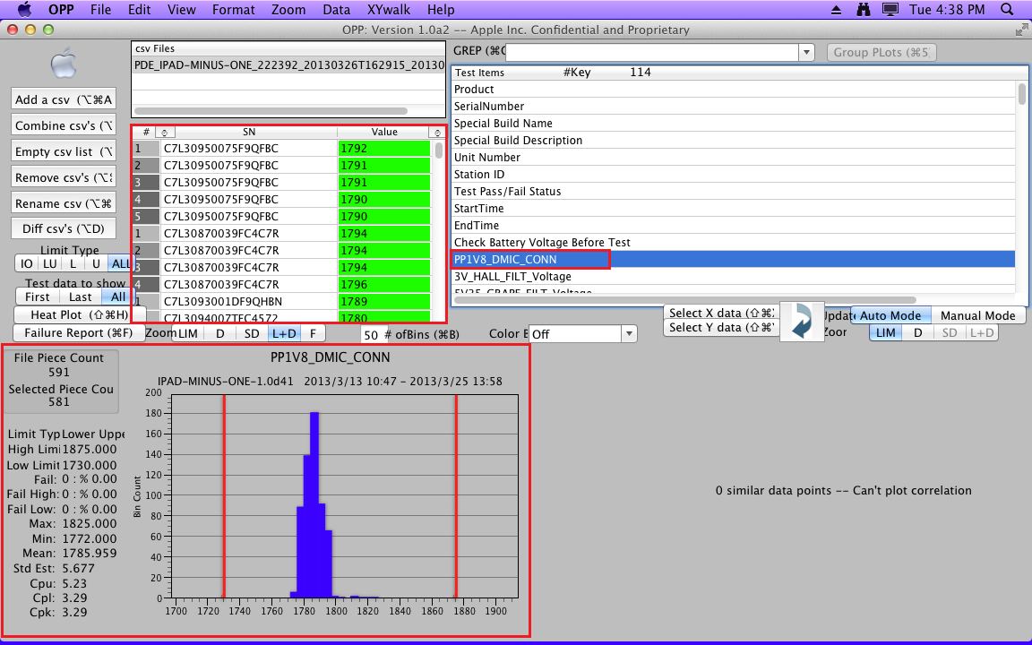

(5)

2. In the end you can use the shortcut “command +1” to save the picture which you needed.

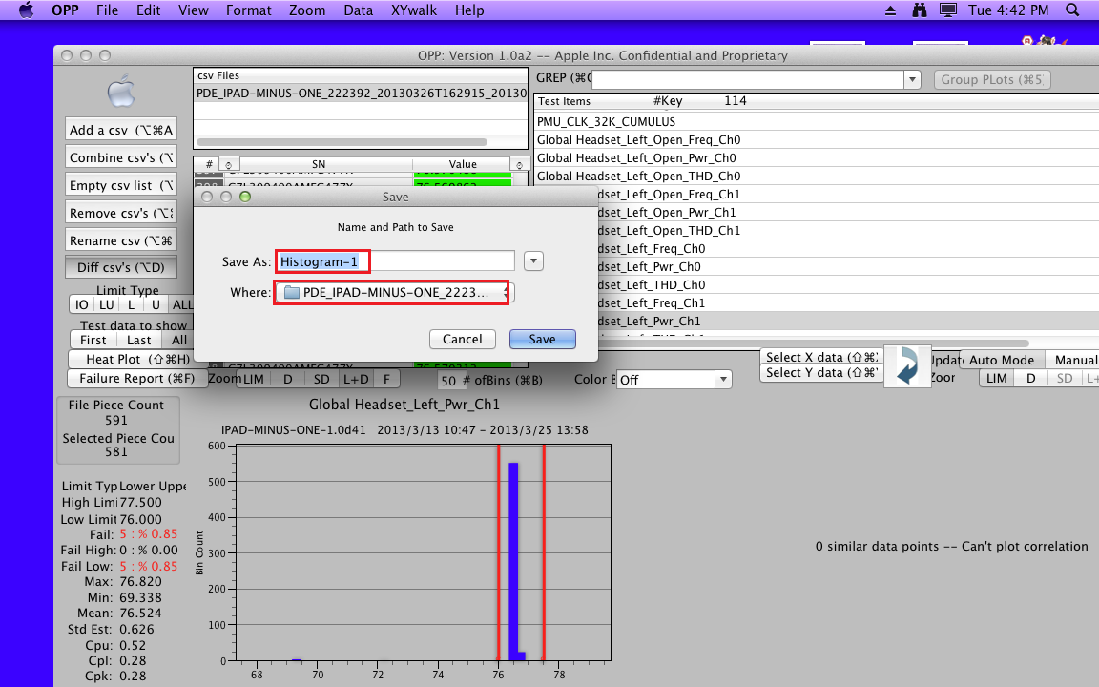

(6)

1. **Application**

In general, we usually use the OPP to draw distribution to finish distribution chart.

The template of distribution chart is as below:

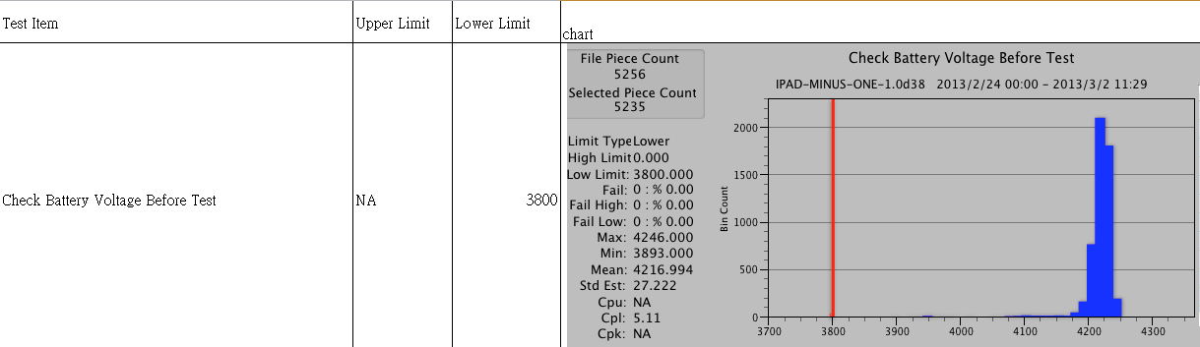

(7)

It contains 4 items:

(1) Test Item

(2)Upper Limit

(3)Lower Limit

(4) Chart.

1. **How to drawing the distribution chart?**
2. Log in QCR to download summary log.

The URL of QCR

The UI of QCR

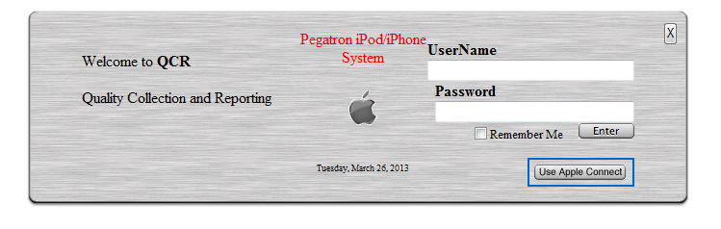

(8)

After log in the QCR, you can see some items as below.

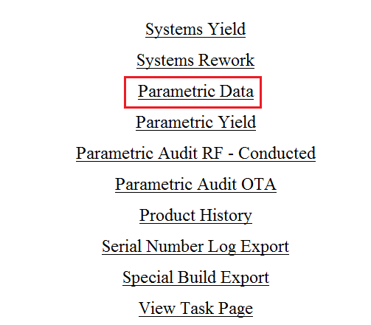

(9)

1. We can choose the Parametric Yield to download the summary log which was in a certain period of time.
2. Setting a certain period of time

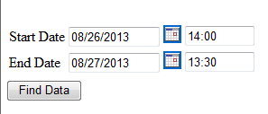

(10)

1. Selecting the type of unit、test station、the version of the overlay and other items.

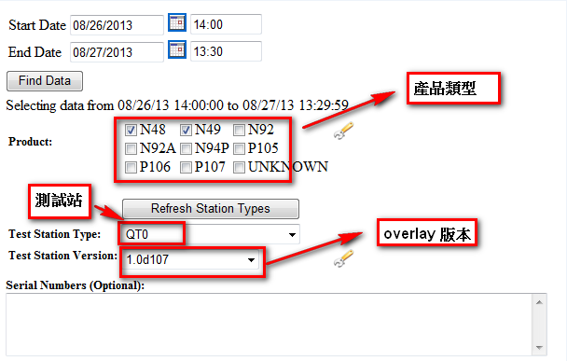

(11)

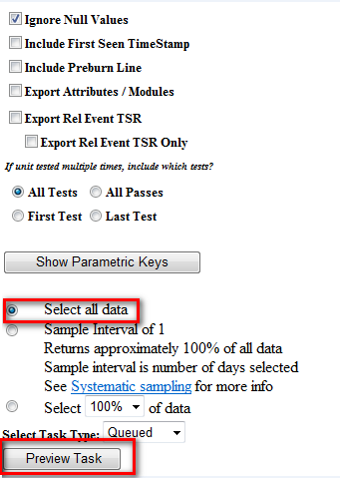

(12)

1. Create Task and there will be an icon of folder on the upper left corner. It show that you have create a new queued successfully.

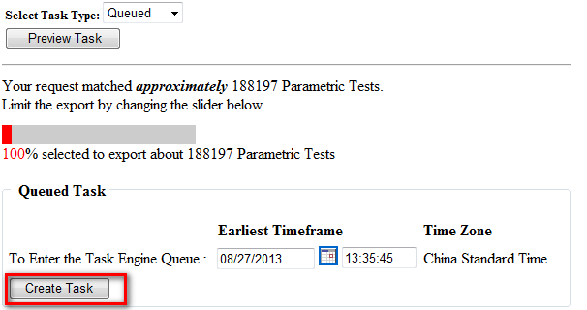

(13)

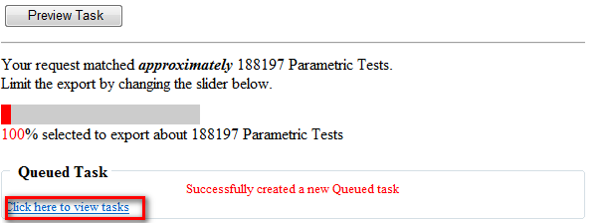

(14)

6. Download the summery log.

When the icon of file turn to be arrow it means that the summery log have been download successfully. You can click the arrow and download the summery log to your computer.

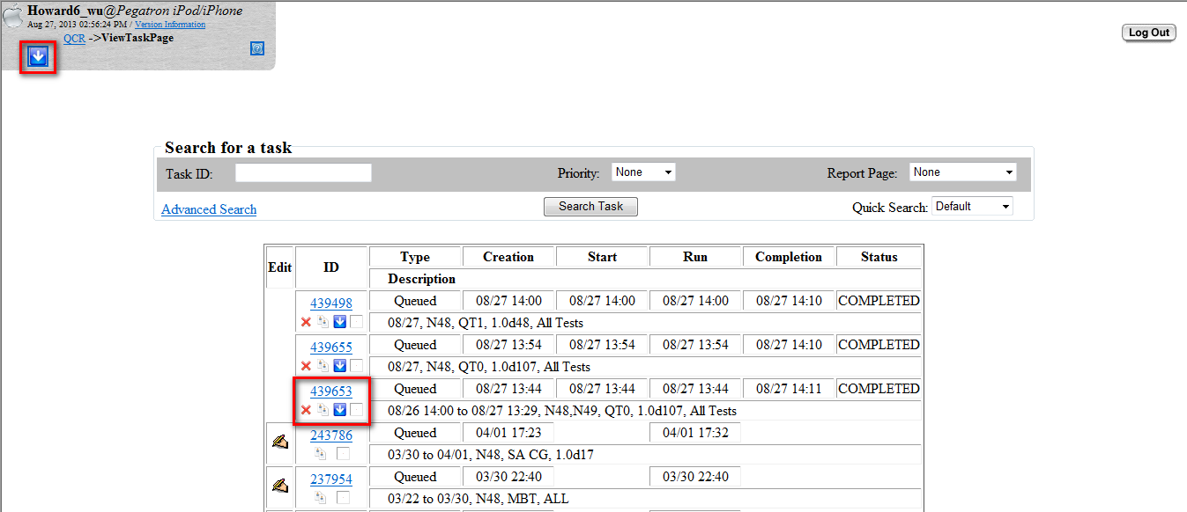

(16)

1. After dealing with the summery log, we can use the OPP to draw distributions as the steps that we previously mentioned. In the end you can paste the picture and type the content manually.

The final result is as below:



(17)

Home work

Download a piece log from QCR at the station of QT0 or QT1 to draw distribution.